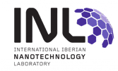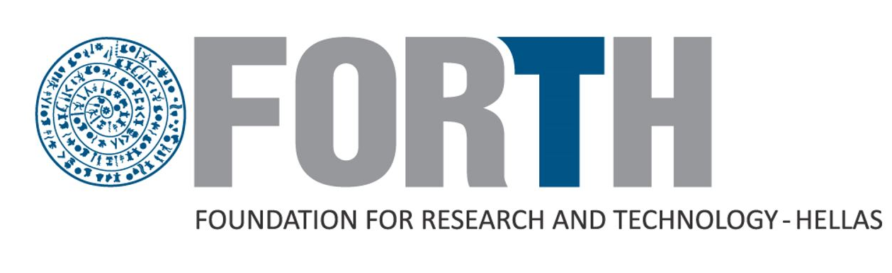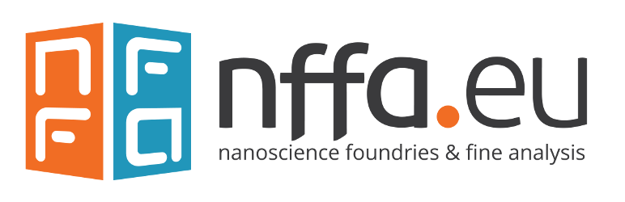

1st Nffa.eu Pilot Training School

Tentative Programme
Tuesday 27 September

Registration | 08:30 - 09:00
Welcome and practical information | 09:00 - 09:30
Transmission Electron Microscopy I, INL* | 09:30 - 10:30
POSTER Session & Coffee-Break | 10:30 - 11:00
Transmission Electron Microscopy II, INL* | 11:00 - 12:00
Scanning Electron Microscopy, INL* | 12:00 - 13:00
LUNCH | 13:00 – 14:30
FIB, INL* | 14:30 – 15:30
LABORATORIES TOUR | 15:30 – 17:00

Wednesday 28 September

EDX and EELS, INL* | 09:00 - 10:00
POSTER Session & Coffee-Break | 10:00 - 10:30
X-ray Photoelectron Spectroscopy, INL* | 10:30 - 11:30
Non Linear Microscopy and Spectroscopy I, FORTH# | 11:30 - 12:30
LUNCH | 12:30 –14:00
NP Characterization I (Caterina Minelli, NPL, UK) | 14:00 –15:00
POSTER Session & Coffee-Break | 15:00 – 15:30
NP Characterization II (Hiram) | 15:30 – 16:30
Non-Linear Microscopy and Spectroscopy II, FORTH# | 16:30 – 17:30

* Lectures will be presented by INL experts: Oleksandr Bondarchuk, Oliver Schraidt, and Enrique Carbo.
# Lectures will be presented by FORTH experts: S. Psilodimitrakopoulos, E. Stratakis

